# Hookup

1. Don’t remove serial cable from AVR or USB from Amtel-ICE, connections are fragile!
2. **Don’t plug into Outlet power source above 5v.**
3. Plug in serial cable to ICSP header on Arduino.
4. Power Arduino, Plug in to external Power (PC USB to Arduino)
5. Plug in Atmel-ICE usb to computer

# Set Fuses

1. Got to Tools -> Device Programming

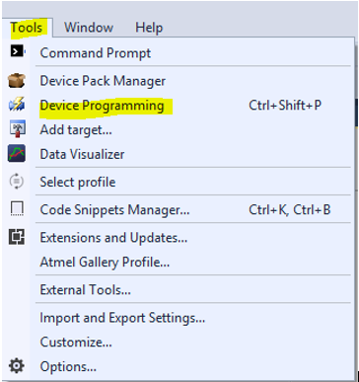

1. Check OCDEN and JTAGEN
2. Un check BOOTRST
3. Click Program button, then Verify Button

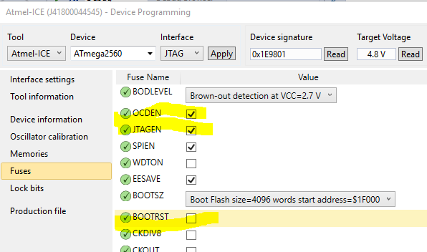

# Debugging

1. In tools select Amtel-ICE debugger and JTAG interface.
2. Run Sketch in Debug.
3. When **DONE** Debugging uncheck OCDEN and JTAGEN fuses and program.

<http://automation.binarysage.net/?p=1515>

<http://blog.alrightythen.de/2014/08/debugging-with-the-new-atmel-ice/>

<http://www.crash-bang.com/debug-atmel-ice/>

<http://forum.arduino.cc/index.php?topic=96401.0>

# Debug Errors

## Timed out waiting for initial target stop event

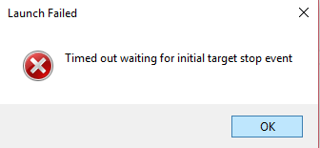

**Resolution**: this happens sometimes on first debug session. Just hit run again.

# Un-Brick

1. Upload Blink through SPI

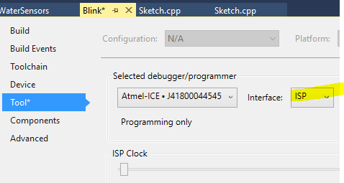

1. Switch back to JTAG

# Pinout

Atmel-ICE Serial Cable: Arduino ICSP Header:

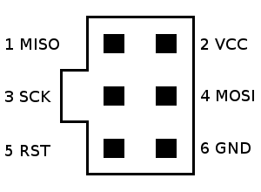 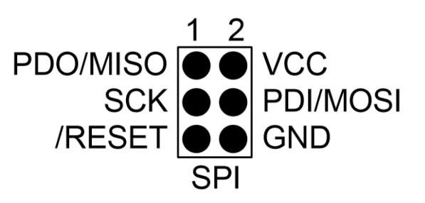

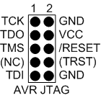

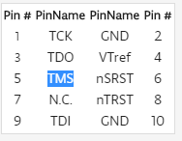 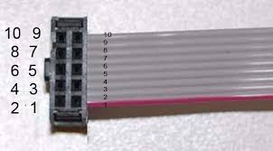

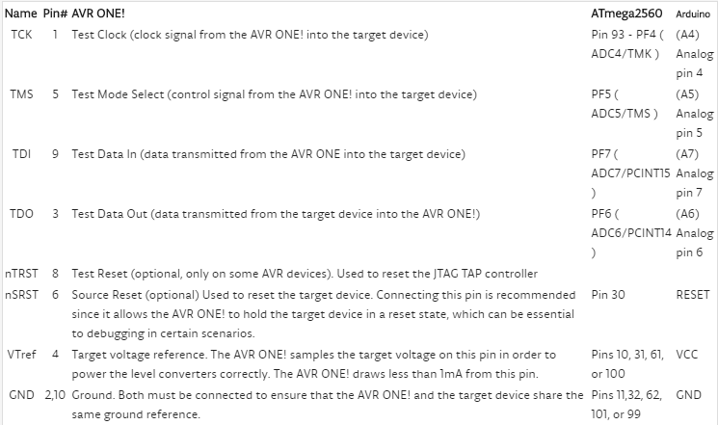

# Diagram

